**Example 1: Shoaling and reflecting of a solitary wave [1]**

A flume experiment conducted by Walkley (1999) presented the shoaling phenomenon when a solitary wave runs up a slope and reflects from a vertical wall. The flume shown in Fig. 1 includes a wavemaker, rigid ramp, rigid end wall, and three wave gauges located at *x* = 55 m, 71.25 m, and 72.75 m. The solitary wave propagates to the +*x* direction as the incidence. The amplitude of the solitary wave is 0.07 m. Since the depth-averaged horizontal velocity can be imposed by:

( 47

where is the water depth and is a function of the amplitude of the solitary wave. The numerical solution with the series expansion up to the ninth order provided by Fenton (1972) can be useful in this example.

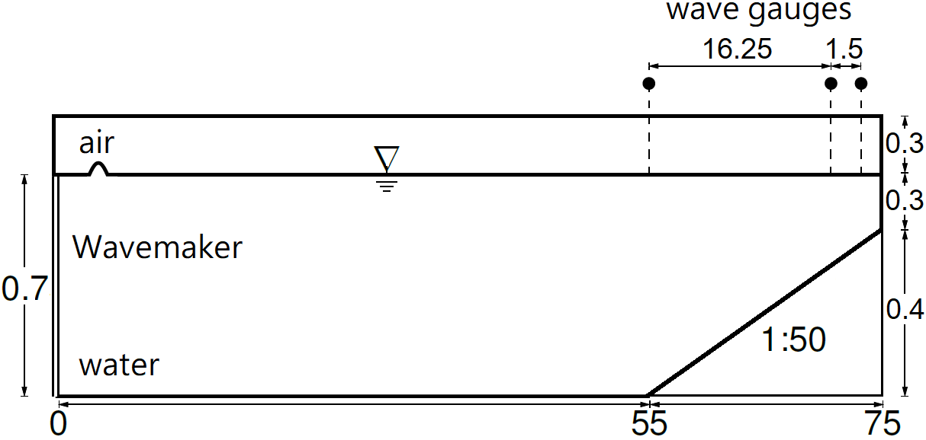

**Fig. 1.** The bottom topography of the test case of solitary wave reflection after running up a slope (not to scale).

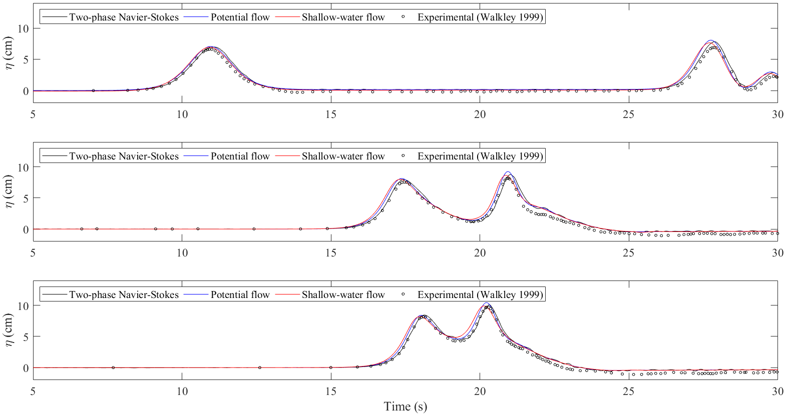

**Fig. 2.** The wave elevations in the test case of a solitary wave reflection after running up a slope at (a) *x* = 55 m, (b) *x* = 71.25 m, (c) *x* = 72.75 m.

**Example 2: Periodic waves propagate over a submerged bar [2]**

The numerical methods are verified by the experiment of the periodic waves propagate over a submerged obstacle conducted by Beji and Battjes (1994). The experimental configuration can be referred to published paper (Beji and Battjes, 1994). It includes a wavemaker, submerged trapezoidal bar, absorption ramp, and seven wave gauges as shown in Fig. 3. The wave gauges are located at *x* = 5.7 m, 10.5 m, 12.5 m, 13.5 m, 14.5 m, 15.7 m, and 17.3 m. According to their suggestion, the radiation condition is set on the outlet boundary. To avoid the reflected wave of the nonlinear wave from the radiation condition (Ohyama and Nadaoka, 1991), the absorption zone is added in front of the outlet to ensure the leaving wave is linear. Therefore, the dynamic boundary condition on the free surface is rewritten as:

( 48

where is a linear function within [18.95, 37.7] with zero at = 18.95 m and 1.2 s-1 at = 37.7 m. The wave height is 0.02 m and the wave period is 2 s recorded in the original paper, but Guermond et al. (2022) correct the wave period as 2.01975 s for the numerical verification. Therefore, the periodic waves are generated by given the horizontal displacement of the piston type wavemaker as:

( 49

Note that the amplitude of the wavemaker is computed according to the linear wavemaker theory (Ursel et al., 1960). The unit is meter.

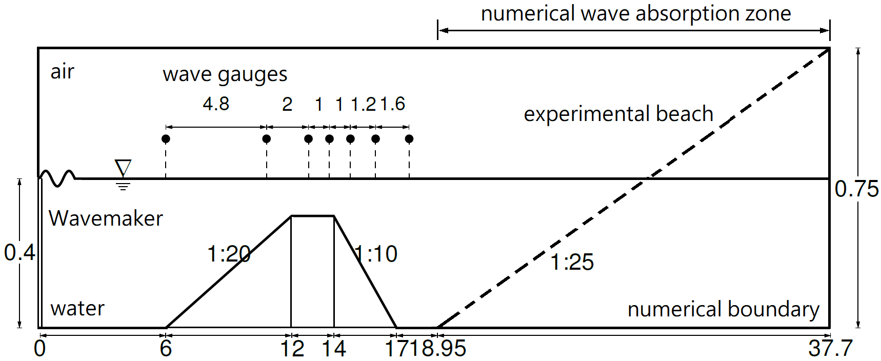

**Fig. 3.** The experimental and numerical configurations of the test of periodic waves propagate over a submerged obstacle (not to scale).

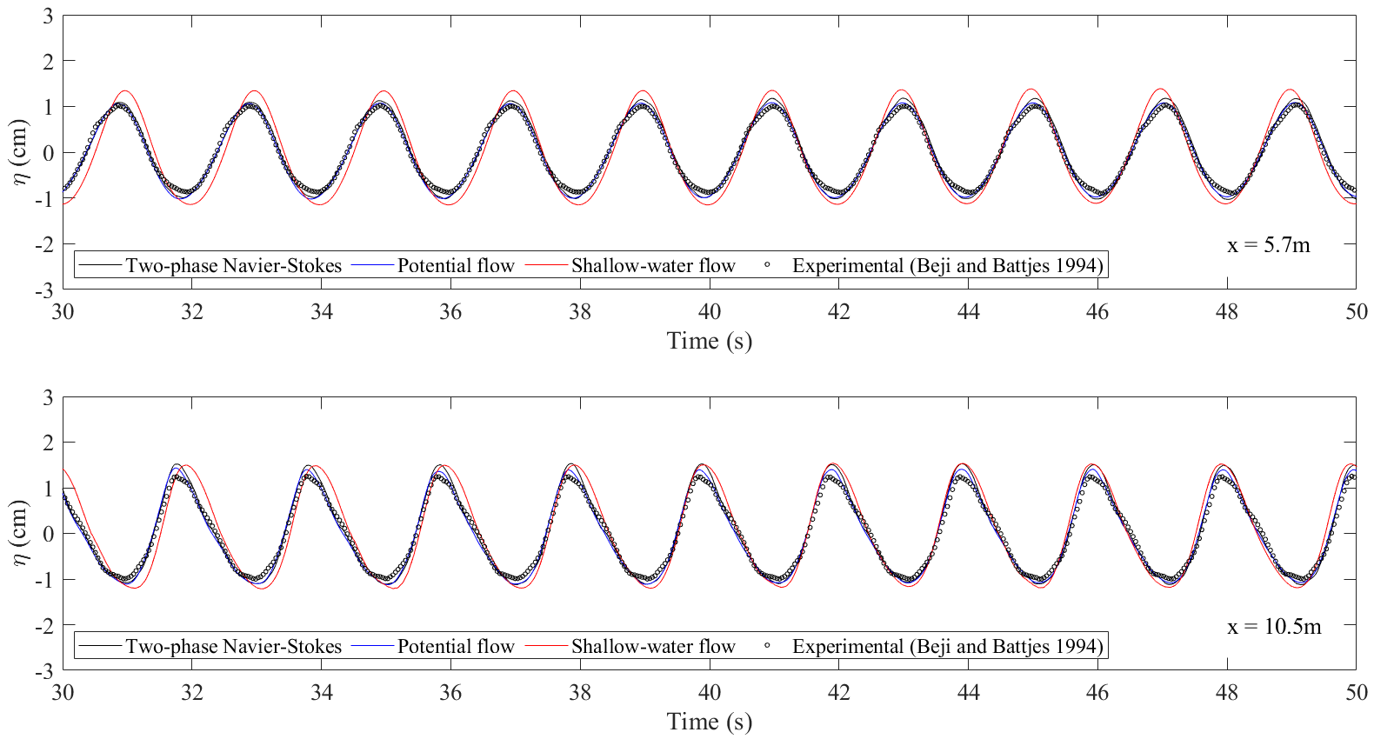

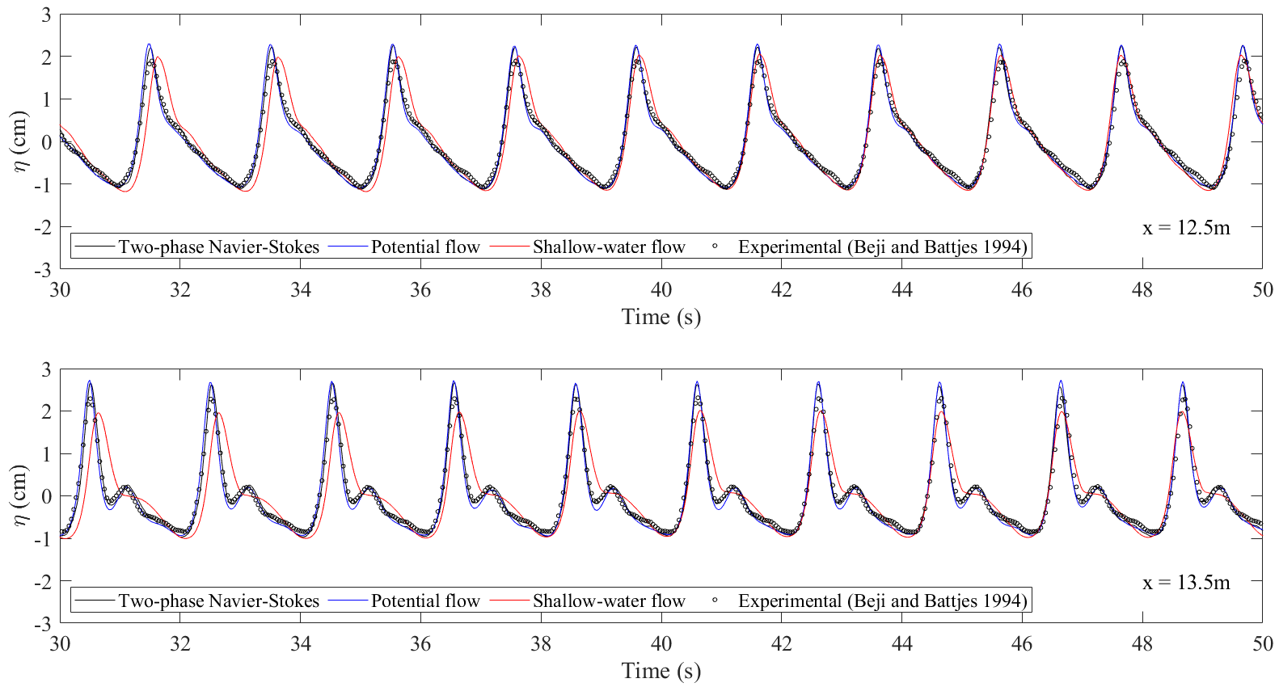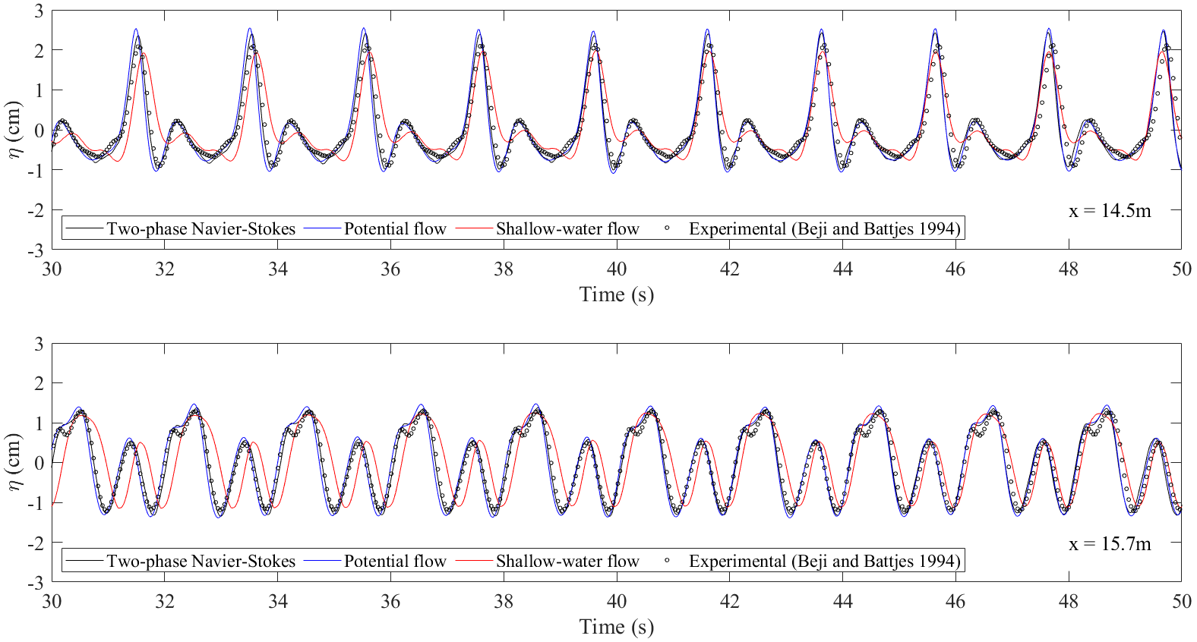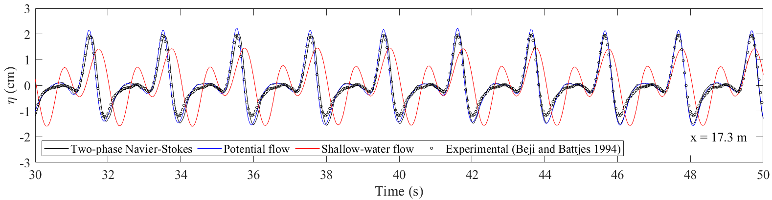

**Fig. 4.** The steady-state numerical and experimental wave elevations at the locations of the wave gauges when the periodic waves passing over a submerged obstacle.

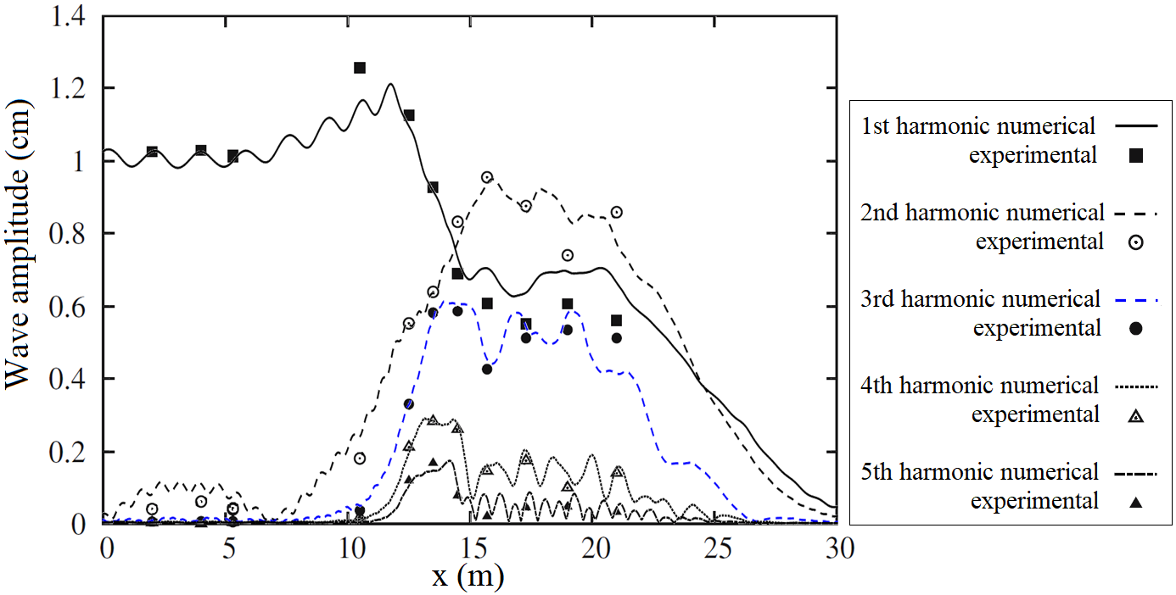

**Fig. 5.** The experimental and numerical steady-state wave amplitude of the first five harmonic components of the wave elevations by two-phase RANS model for different locations.

**Example 3: Tsunami impinges and overtops a seawall [3]**

In this example, the experiments of a tsunami-like solitary wave overtopping an impermeable seawall conducted by Hsiao and Lin (2010) are reproduced through present methods. Fig. 6(a) shows the layout of the experimental flume and Figs. 6(b) and (c) show the pressure transducers and wave gauges installed within the flume, respectively. The experimental configuration can be referred to published paper (Hsiao and Lin, 2010). Three experimental conditions with different offshore wave heights and water depths listed in Table 1 are used in this example.

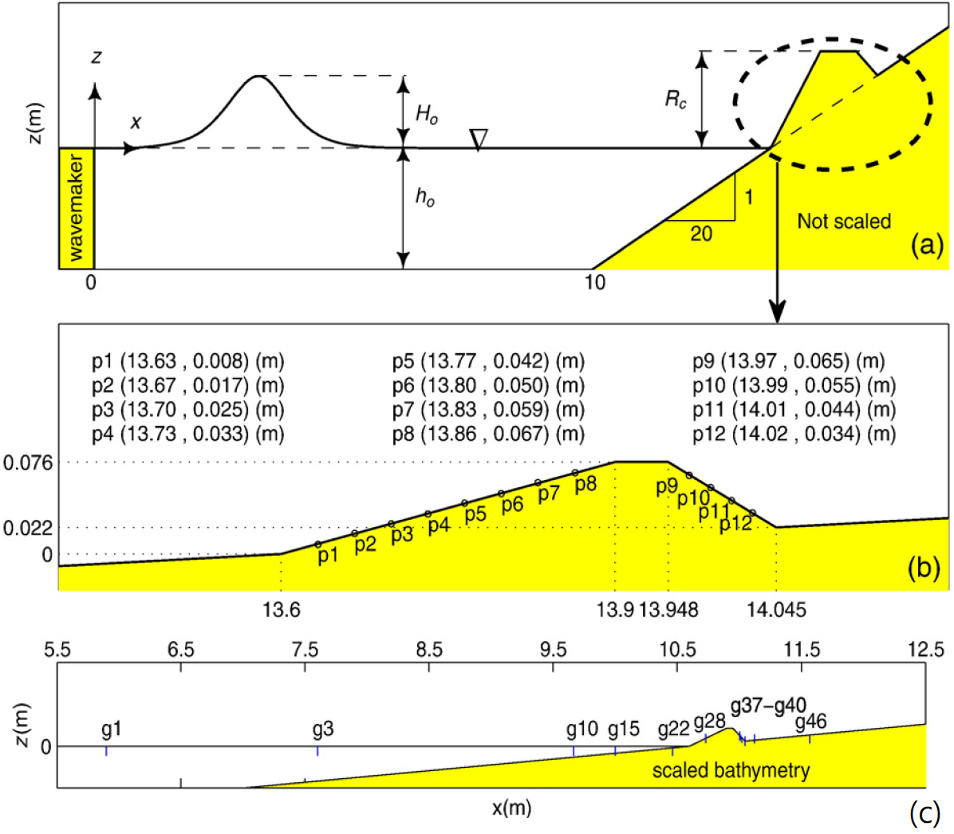

**Fig. 6.** The sketch of (a) wave flume layout for the overtopping wave experiment, (b) locations of each pressure transducer along the seawall, and (c) locations of each wave gauges (Hsiao and Lin, 2010).

Table 1: Experimental conditions of presented tsunami cases.

|  |  |  |  |
| --- | --- | --- | --- |
|  | (m) | (m) |  |
| Case 1 | 0.2 | 0.07 | 0.35 |
| Case 2 | 0.22 | 0.0638 | 0.29 |
| Case 3 | 0.256 | 0.0589 | 0.23 |

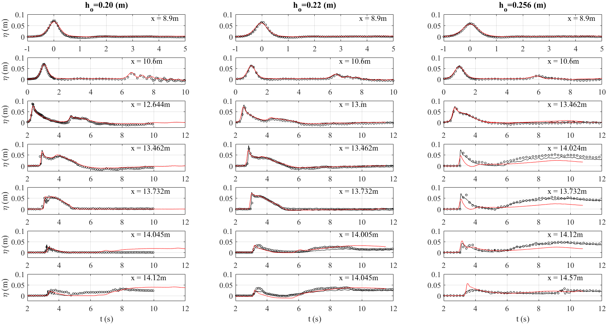

**Fig. 7.** The experimental and numerical wave elevations when the wave runs up a slope and overtop a seawall for different wave conditions (circle: experimental, black line: RANS, blue line: potential flow, red line: SWE).

**Reference**

1. Walkley, M.A. A numerical method for extended boussinesq shallow-water wave equations. Ph.D. Thesis, University of Leeds, Leeds, UK, September 1999.
2. Beji, S. and Battjes, J.A., 1994. Numerical simulation of nonlinear wave propagation over a bar. Coastal Engineering, 23, 1-16.
3. Hsiao, S.C. and Lin, T.C., 2010. Tsunami-like solitary waves impinging and overtopping an impermeable seawall: Experiment and RANS modeling. Coastal Engineering, 57, 1-18.